**RTicketFinder**

Created by students of the group AMI-32:

• Appazov Nadir

• Gaiduchyk Svitlana

• Petravchuk Anastasiya

• Yuras Nazar

**Customer:**

Business Tech. Inc

**Description:**

**RTicketFinder** is a desktop application, which designed to quickly searching for railway tickets according to certain filters.

An authorized user can buy a railway ticket, found specifying all necessary search criteria, which will be added to his basket, and, if necessary, at least an hour before the departure, the ticket can be returned with a refund. Also, authorized user can book the tickets for the future date.

An unauthorized user can find the tickets by necessary criteria, see all information about trip but can not book or buy the tickets.

**Type of application:**

Desktop application

**Instruments:**

• **Developing:** Microsoft Visual Studio

• **UI:** Balsamiq

• **Database:** Microsoft SQL Server

**Non-functional requirement**

• **Interface language: English**

**Wireframes:**

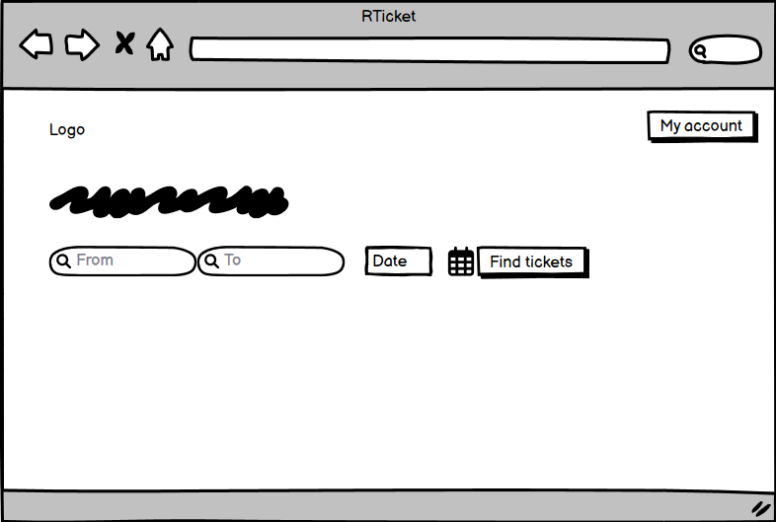

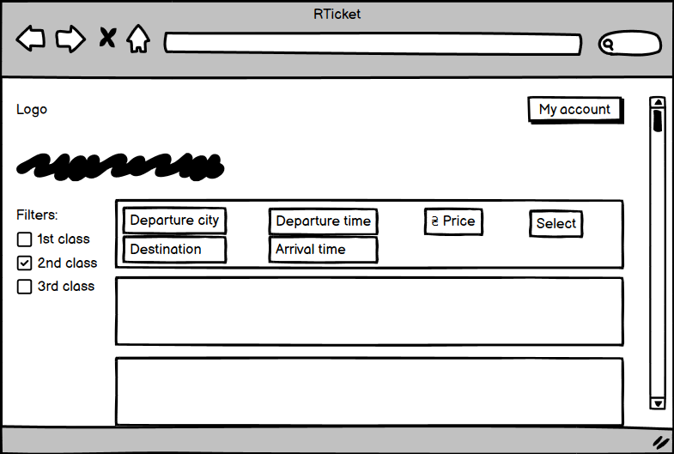

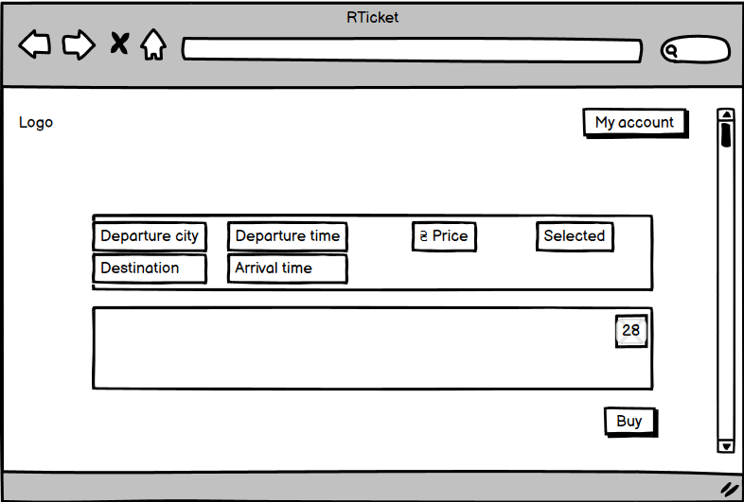

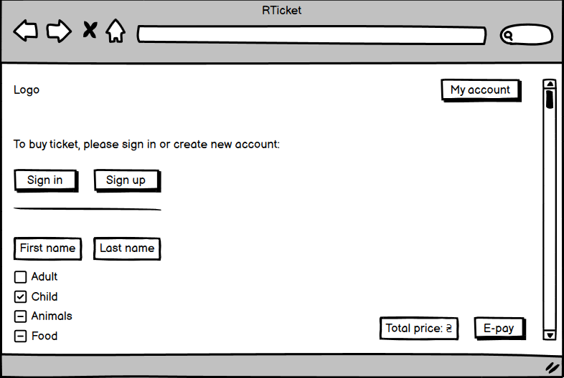

**Use-case diagram:**

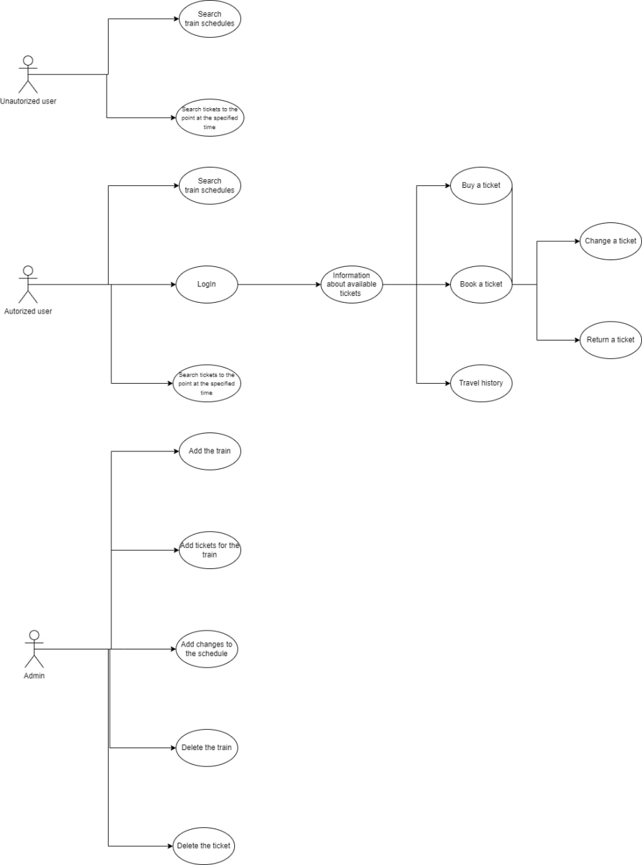

**Requirement manager:**

1. **As user, I can log in system:**

• User not authorized in system

• User already has an account

1. **As user I can create a new account:**

• User do not have an account yet

• User fills a necessary fields like e-mail address, name, surname, password (at least 8 symbols)

1. **As user, I can look for the tickets**

• User can be both authorized or not authorized

1. **As user, I can buy the ticket:**

• User must be authorized

• User must fill a necessary fields: point of departure, point of arrival, type of wagon(1st class, 2nd class, 3rd class), payment type

1. **As user, I can book a ticket:**

• User must be authorized

• User must pay 10% of price of a ticket for booking, and pay the rest of the price within 24 hours before departure, otherwise the ticket will be returned to sale

1. **As user, I can return the ticket:**

• User must have the ticket

1. **As user, I can see my travel history**

• User must be authorized